CSE 4571 – PRACTICAL ROBOTICS PROJECTS WITH ARDUINO

EXPERIMENT 3
SERVO MOTOR CONTROL FOR POSITION-BASED ROBOTIC ACTUATION
Duration | Level | Mode | CO Mapping
2 Hours | B. Tech CSE Final Year | Hardware / Wokwi | CO2, CO3
1. Aim of the Experiment
To control a micro-servo using a potentiometer as a position command.
2. Objectives
- Interface a servo.
- Read an analog command.
- Map ADC values to angular position.
- Demonstrate a robotic actuator.
3. Components / TinkerCAD/ Wokwi Parts
Component | Quantity | Purpose
Arduino UNO | 1 | Microcontroller
Micro Servo | 1 | Position-controlled actuator
Potentiometer | 1 | Analog position command
Breadboard | 1 | Circuit assembly
Jumper wires | As required | Interconnections
4. Theory
A hobby servo interprets control pulses as a target position. The Arduino Servo library provides a simple interface. The potentiometer provides an analog command at A0, and its ADC reading is mapped from 0–1023 to a servo command of 0–180 degrees.
ADC range: 0–1023 → Servo command range: 0–180°
5.Pre-Lab Questions
- What is PWM?

- Why is a servo different from a DC motor?

- What does map() do?

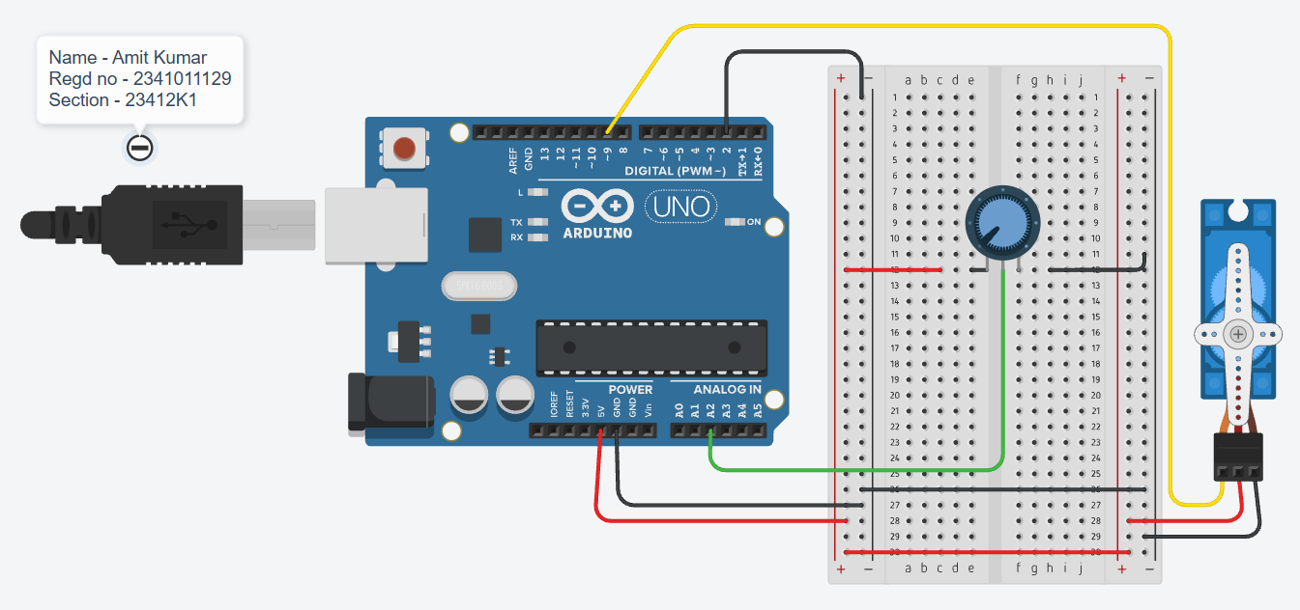
5. Circuit Diagram
Figure 1. Verified potentiometer-to-servo position-control wiring.
6. Connection Table
Component / Signal | Arduino Pin | Connection Details
Servo signal | D9 | Position-control signal
Potentiometer SIG | A0 | Analog command
Potentiometer VCC | 5V | Supply
Potentiometer GND | GND | Ground
Servo VCC | 5V | Supply
Servo GND | GND | Ground
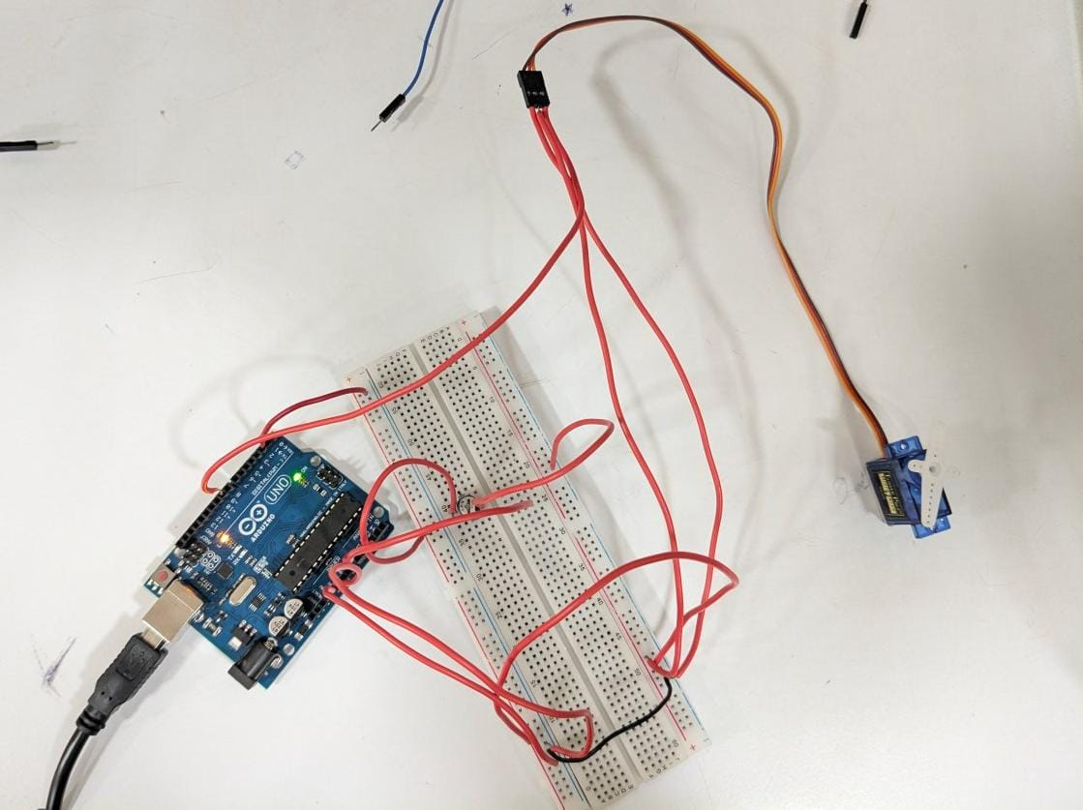
7. Circuit Diagram Implemented Using Hardware’s
Figure 2. Hardware Implemented & Verified potentiometer-to-servo position-control wiring.
8. Procedure
- Place Arduino UNO, potentiometer and micro servo in the Wokwi project.
- Wire the circuit exactly as shown in Figure 1.
- Upload/run the program.
- Open Serial Monitor at 9600 baud.
- Move the potentiometer through its range.
- Observe the servo movement and corresponding commanded angle.
- Record five ADC/expected-angle/observed-angle pairs.
- Restrict the operating range as an exercise.
9. Arduino Program
#include <Servo.h>
int inputpotent = 0;
int outputservo = 0;
Servo servo_9;
void setup() {
pinMode(A0, INPUT);
servo_9.attach(9);
}
void loop() {
inputpotent = analogRead(A0);
outputservo = map(inputpotent, 0, 1023, 0, 180);
servo_9.write(outputservo);
delay(10); // Delay a little bit to improve simulation performance
}
10. Observation Table
Sl. No. | ADC | Expected Angle (°) | Observed Angle (°)
1 | 900 | 158 | ≈158
2 | 696 | 122 | ≈122
3 | 511 | 89 | ≈89
4 | 348 | 61 | ≈61
5 | 164 | 28 | ≈28
11. Expected Output / Analysis
As the potentiometer is rotated, the ADC reading changes. The program maps this input to approximately 0°–180°, and the servo moves toward the corresponding position. The Serial Monitor reports the ADC reading and commanded angle.
12. Result
The micro-servo was successfully controlled using the potentiometer as an analog position command. The ADC-to-angle mapping and corresponding servo movement were verified in Wokwi.
13. Post-Lab Questions
- Restrict the servo angle to 20–160 degrees.

- Add preset positions using a pushbutton.

- What does Servo.attach() do?

- Why is position control useful in robotics?

14. Precautions
- Verify pin assignments before running the simulation.
- Use common ground for connected devices.
- Do not short the potentiometer signal node to 5V or GND.
- Record both the input condition and observed output.
- For physical implementation, verify servo supply capability, current demand and mechanical loading.
15. Suggested Extension
Modify the program to add one meaningful feature, document the change, and preserve the original behavior as a baseline.
#include <Servo.h>
Extension: Added Serial Monitor feedback to display the ADC value and corresponding servo angle while preserving the original potentiometer-based servo control. The original program behavior remains unchanged, and the added feature provides real-time monitoring of the commanded position.
int inputpotent = 0;
int outputservo = 0;
Servo servo_9;
void setup() {
pinMode(A0, INPUT);
servo_9.attach(9);
Serial.begin(9600);
}
void loop() {
inputpotent = analogRead(A0);
outputservo = map(inputpotent, 0, 1023, 0, 180);
servo_9.write(outputservo);
Serial.print("ADC: ");
Serial.print(inputpotent);
Serial.print(" Servo Angle: ");
Serial.println(outputservo);
delay(10);
}
16. Student Record
Amit Kumar | 2341011129
Student Name | Registration No. | Date | Faculty Signature

